**Wet season monitoring**

**Report**



**November 2014**



**Nature***Kenya* Improving Livelihood through Sustainable Government, Ngo, Private Partnerships in South Nandi Forest, Kenya Project

**MONITORING AND BIRD WATCHING**

**Background**

Monitoring is a vital part of conservation programmes providing an early warning of any emerging problems, and is critical in assessing the impact of conservation effort. A monitoring scheme is designed so that data can be collected routinely and on a sustainable basis without being an overburdening data collection exercise.

In Kenya there are 62 Important Bird Areas (IBAs) and South Nandi forest is one of them. The monitoring framework for IBAs currently functioning in Kenya implements Article (7) of the Convention on Biological Diversity on identification and monitoring. Monitoring requires a two-tier approach that should be based on the ‘pressure-state-response’ model. The first tier is the basic monitoring taking place in all IBAs whereby a monitoring form is filled in by the participating institutions i;e KFS, KWS and NEMA. The second tier is the detailed monitoring that currently takes place in 12 sites in Kenya with well established and functioning SSGs whose members have trained by Nature Kenya and NMK together with WCK staff to identify the target species.

The South Nandi Biodiversity Conservation Group (SONABIC) is the SSG undertaking detailed monitoring in the South Nandi forest. Since 2006 when the monitoring scheme was established, the SSG has continued to undertake the monitoring twice a year; once in the dry season (Jan-Feb) and one in the wet season (Jun-July) depending on weather condition of the particular time.

This year’s wet season monitoring altered due to prolong rainy season and it was shifted to November.

**Objectives**

The objectives of the monitoring are:

* To identify how the structure of the forest is changing over time and the causes of the change.
* To determine what impact this is having on forest birds
* To establish how the number of some key bird species are changing over time
* To know which part of the forest needs more conservation action

**Progress**

The activity took place on the transect plots established by the SONABIC within the South Nandi Forest. The 2-day activity took place in November 2014.

This was carried out by SONABIC members with the invited participants from;

1. Representatives from satellite groups
2. Birders trained by Nature Kenya
3. Forest scouts
4. KFS rangers

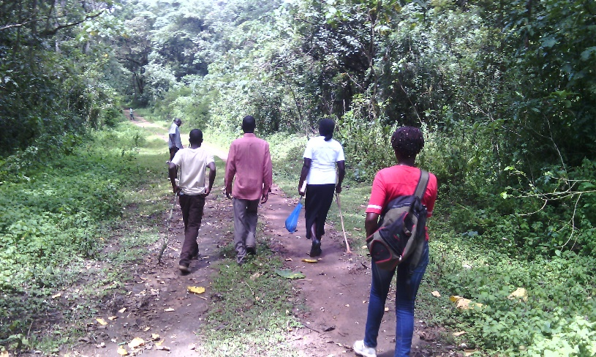

SONABIC members took the lead in locating the transect plots in the forest and in data collection. Data collected were filled into the standard detailed monitoring forms. Thereafter, the data were compiled and analyzed to give the desired information, the data is attached at the back of this report.

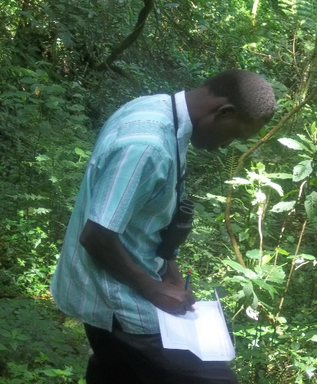

The monitoring information is meant to inform decision makers on the level of threats (pressure) on the forest, the current status of the forest and the appropriate response to deal with the threats i.e conservation action.

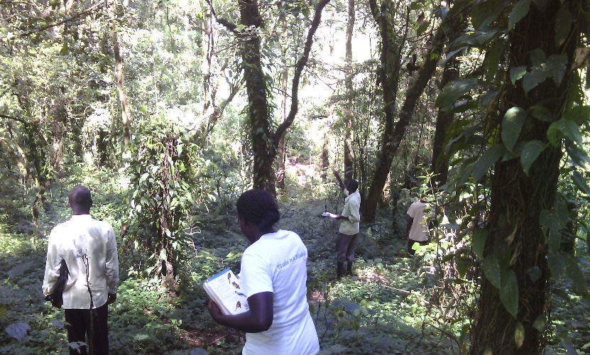

**Recommendation**

From the data collected, it is regrettable and unfortunate that the wood fuel which has always seemed to be a low impact resource extraction by the local communities, is, infact an ecological disastrous process. The forest department should revise the policy of wood fuel extraction to provide for retention of the absolute minimum critical for the survival of the threatened tree and bird species.

Any policies to exploit indigineous forest must take into account the effects on endemic and other globally threatened species that are very sensitive to any slight changes in their habitat i.e Turners’ Eremomella *(eremomella turneri),* including other flora and fauna.

The grazing of livestock within the forest has led to fast degradation of the indigenous forest. The forest department together with the county government needs to develop strategies for reducing the number of livestock grazing in the forest, availing water outside the forest boundaries and working with the farmers to avail fodder outside the forest, i.e only the controlled number of livestock to be allowed to graze in the forest within a given period of time particularly the rainy season and stopped during the dry season.

The other forest uses like bee keeping which has higher returns and have minimum effect on the forest dependent species should be worked out, capacity building amongst the public should be created to improve on the harvesting of honey in the forest to avoid felling of the aged growing tree in the name of honey.

The upcoming CBOs should supported to enhance the protection of biodiversity through advocacy, creating awareness in the local community and any habitat restoration programmes.

**Conclusion**

From the results of the data, it is concluded that :-

* Bird population size is proportional to habitat quality.
* As the forest is disturbed, the forest specialist bird species decrease.
* The distribution and abundance of bird communities is positively correlated with the habitat quality.
* Endo-parasite load is higher in birds occurring in more disturbed site of the habitat.

**The Budget**

|  |  |  |  |  |  |
| --- | --- | --- | --- | --- | --- |
| **No.** | **Description** | **Unit** | **Unit Cost** | **Days** | **Amount** |
| 1. | Fuel -Two motor bikes |  |  | 2 | 2,000 |
| 2. | Invited birders transport + Lunch | 1 | 500 | 2 | 1,000 |
| 3. | Lunch Sonabic members | 10 | 300 | 2 | 6,000 |
| 4. | Lunch  Representatives from satellite groups | 3 | 300 | 2 | 1,800 |
| 5. | Lunch for KFS rangers | 2 | 750 | 2 | 3,000 |
| 6. | Lunch for Community forest scouts | 1 | 500 | 2 | 1,000 |
| 7. | Communication |  |  |  | 1,200 |
|  | **Total** |  |  |  | **16,000** |