**SOUTH NANDI BIODIVERSITY CONSERVATION GROUP (SONABIC)**

**SUB PROJECT TITLE: UPPER CHEPKONG’ONY SOIL CONSERVATION, SPRING AND RIVERBANK PROTECTION PROJECT**

**DISBURSEMENT: PHASE 1**

**IMPLEMENTATION PERIOD: FEB - JUNE**

**CONTACT PERSONS: PETER KIPTANUI 0720 658156**

**SAMSON KIMUTAI 0712 152803**

**TOTAL PROJECT COST: 5,364,100.00**

**1ST DISBURSEMENT AMONT: 528,560**

**TOTAL COMMUNITY CONTRIBUTION: 1,634,400.00**

**1ST DISBURSEMENT COMMUNITY CONTRIBUTION: 657,500**

**BACKGOUND OF THE GROUP**

South Nandi Biodiversity Conservation Group (SONABIC) is a community-based group in Chepkong’ony sub-location that was formed in 1999 and registered with the District Social and Gender Development office in 2004.The group has 31members, 10 females and 21males.

Over the past, the group has been involved in HIV/AIDS awareness with the help of the Public Health officer in Kaptumo Health Centre. However, due to lack of funds, the activity was abandoned in 2003. Other activities that the group engages in include beekeeping using Langstroth beehives, tree nursery with a capacity of 50,000 seedlings, environmental education in 13 schools, forest and bird monitoring, forest rehabilitation, organizing World Environment Day celebrations since 1999, annual tree planting exercises, fish farming, and doing exhibitions and field days with the Ministry of Agriculture.

In undertaking the above activities, SONABIC has been working with the Ministry of Agriculture, Kenya Forests Service, Nature Kenya, National Museums of Kenya, Baraka Agricultural College-Molo, Wildlife Clubs of Kenya, National Environment Management Authority, African Beekeepers Ltd, Honey Care Africa Ltd, Kenya Commercial Bank, Nyayo Tea Zones Development Corporations, Ministry of Fisheries Development, Nandi Environment Forum, Kenya Forests Working Group, Kundos Water Resources Users Association and Kibirong Education Environmental & Farmers Group.

# Group Objectives

The group objectives are:

* To propagate and rear tree seedlings for afforestation, reforestation, agroforestry and other uses through tree nurseries
* To undertake environmental education programmes through school outreach activities, awareness programmes to communities around the forest and to foster general protection of the South Nandi forest and its resources together with the peri-forest environment
* To utilize biological resources to generate income through
  + Beekeeping
  + Tourguiding
* To undertake AIDS awareness and control programmes for the preservation of the peri-forest community’s future generations’ interests.

**Status of the sub project implementation**

The subproject objective in the current disbursement is;.

To rehabilitate riverbanks along Kaplelwoi, Kamondo, Kapcheluch and Tilolek streams and establishing 59 hectares of on-farm woodlots.

The group has raise 50,000 seedlings with a target of 100,000 seedlings which are to be used in the spring and riverbank protection and woodlot establishment.

The total amount of fund used in the current disbursement is KSH.468,447.50

**COMMUNITY CONSULTATION**

Consultation meeting was held on 27 Feb. 2014 and the community attended the meeting and agreed to cooperate with the project since the project will benefit the community at large.

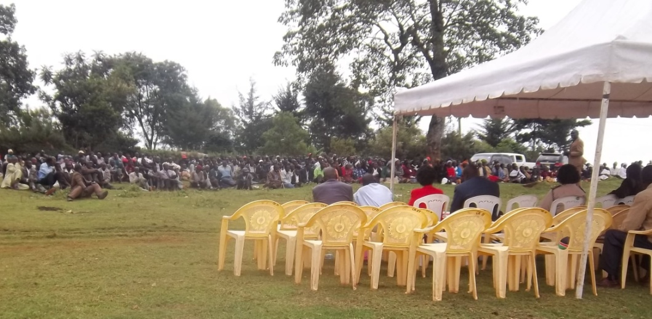

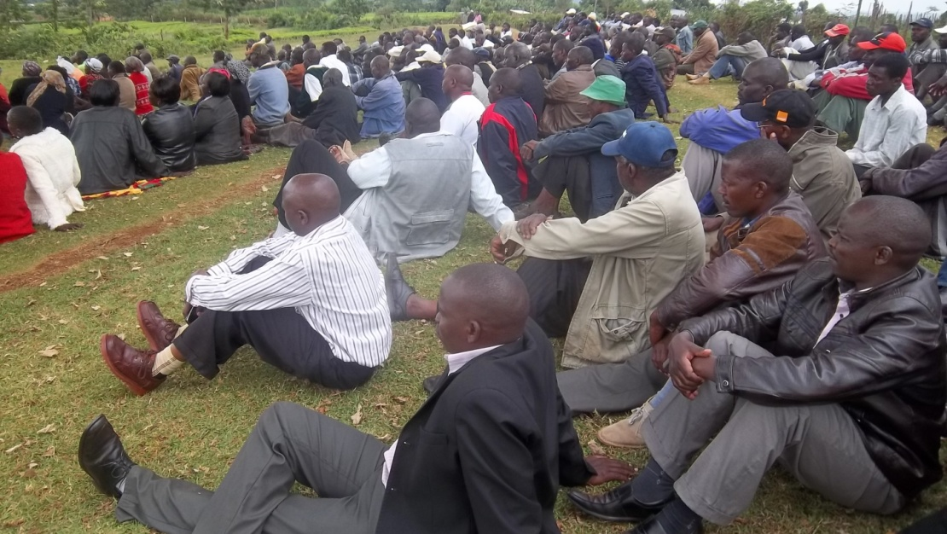

Community consultation on 27/02/2014

**PROCUREMENT OF TREE NURSERY MATERIALS**

The method of procurement used is through competitive bidding. The procurement committees send at least three quotations to three different bidders, after which the quotations were open by the committee and were vetted and the lowest bidder qualify.

The lowest bidder was awarded to supply the tree nursery materials and was received on 4th March 2014

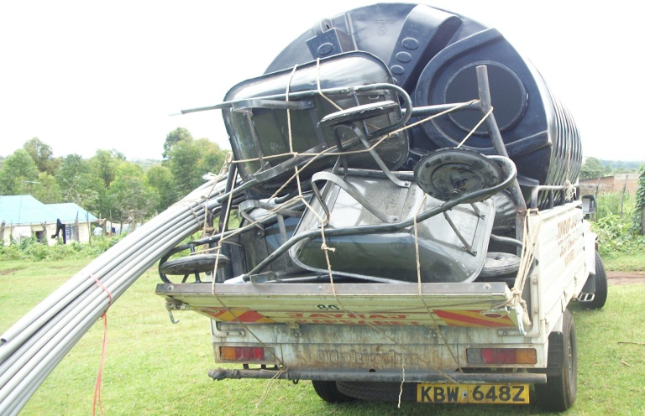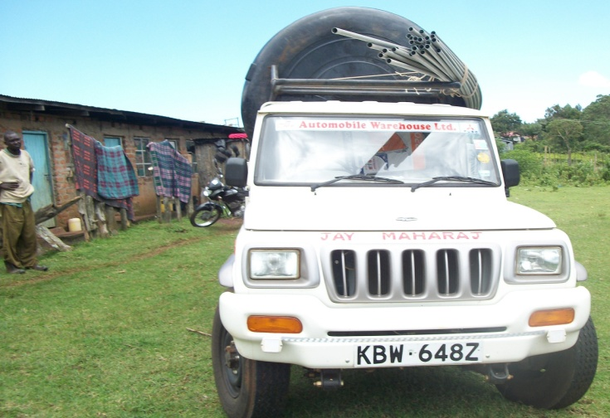

Receiving of tree nursery material and equipments on 04/04/2014

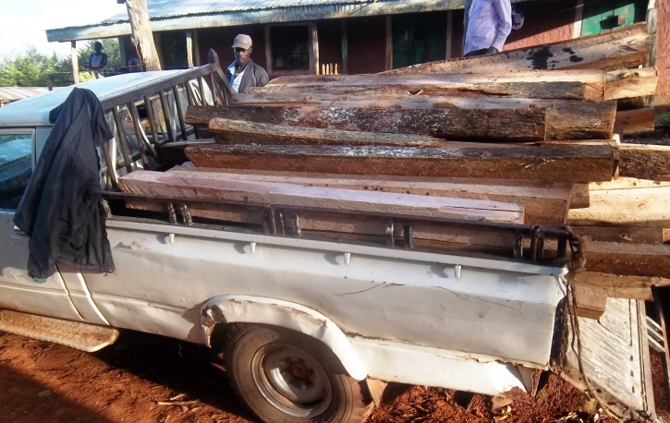 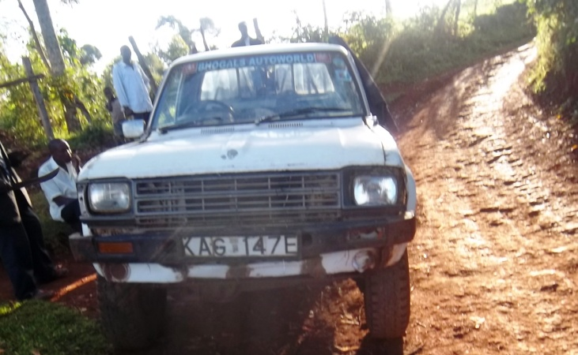

Receiving of post for fencing tree nursery

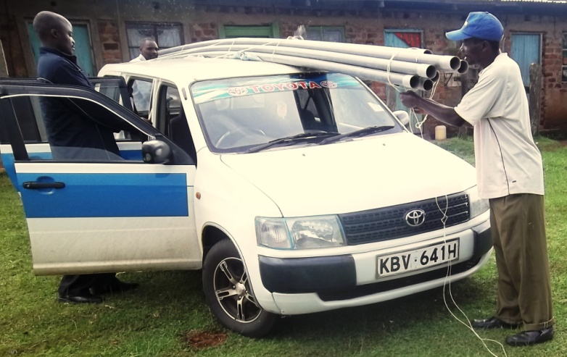 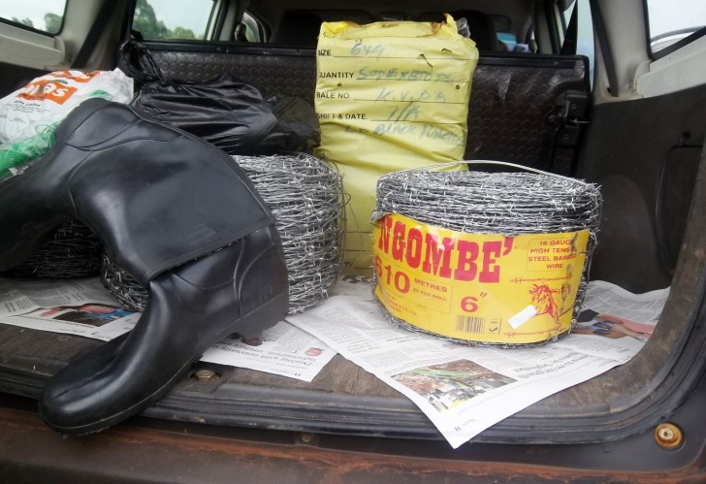

Receiving of fish pond and tree nursery EMP materials

**COMMUNITY CONTRIBUTION**

The community contribution to the project was in kind i.e land for establishing tree nursery, members provide the human labour to lay down pipes to supply water to the tree nursery, clearing of tree nursery, potting 58% of 50,000 poly tubes in the nursery, watering of tree seedlings.

**EMERGING ISSUES/ CHALLENGES**

Wildings of some tree species are not ready for collection hence uses the available tree samplings.

**Benefits**

Through the supply of water to the tree nursery some of the community members have been able to get gravity fed water.

**TREE NURSERY LEVELLING AND POTTING:**

The land to establish tree nursery was cleared and was fence, and the soil to be used for potting was dug, after which the potting started and inserting samplings to the tubes. Also the gravity water was supplied to the nursery to be used for watering tree seedlings.

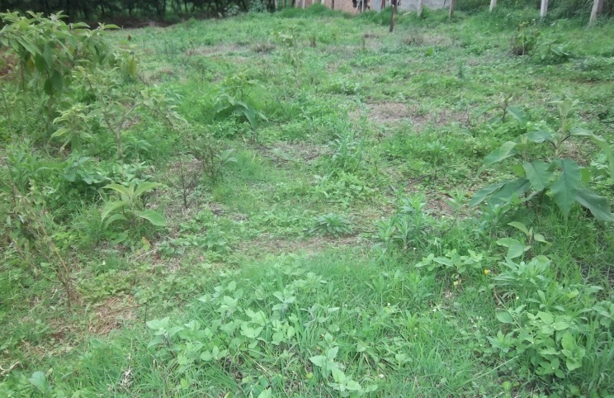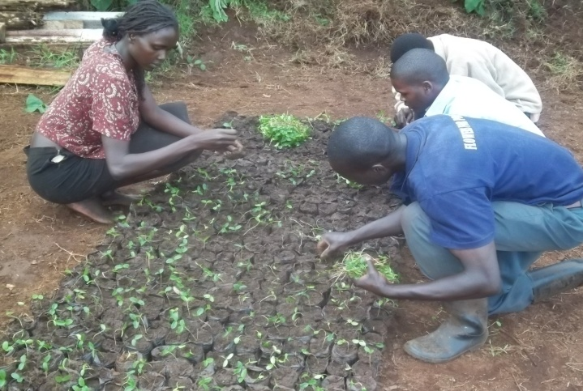

Land before clearing Inserting samplings

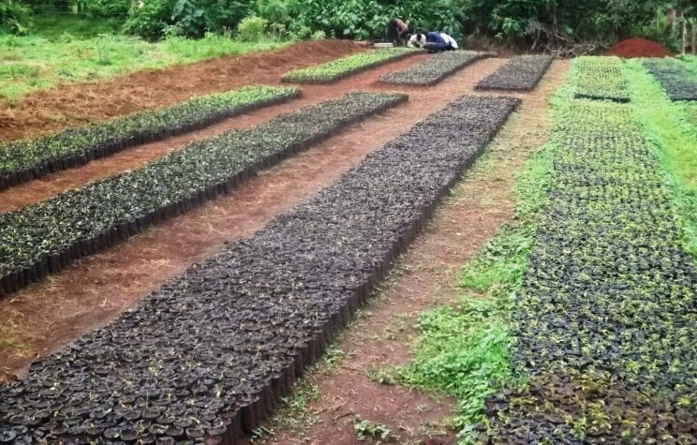 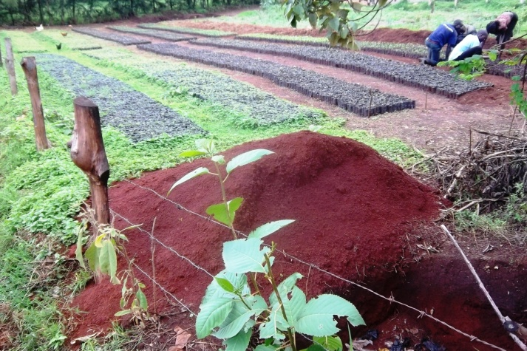

Ongoing tree nursery daily practices

IMPLEMENTATION OF EMP:

|  |  |  |  |  |
| --- | --- | --- | --- | --- |
| **Main Activity** | **Potential Impacts** | **Mitigation Measures** | **Action Taken** | **Status of implementation** |
| Tree nursery establishment | -Loss if soil insitu  -Littering of waste poly tube | -Filling of pit  -Terracing  -Collection and burning of waste poly tubes | -Digging of waste pit  -Waste receptacle  Collecting waste polytubes. | -On going |
|  |  |  |  |  |
|  |  |  |  |  |
|  |  |  |  |  |

**MONITORING & EVALUATION/ VISITATION REPORT:**

|  |  |  |  |  |
| --- | --- | --- | --- | --- |
| **Dates** | **Person(s)/ Team (s)** | **Activity (ies)** | **Recommendation** | **Action Taken by the Group** |
| 31/03/2014 | Shadrack Kirui- Service provider | -Assement of group’s progress on procurement | Use competitive bidding | -competitive bidding to select the lowest bidder. |
| 12/05/2014 | Shadrack – service provider | Assessment of group’s progression on tree nursery and financial materials | Go on with potting | * On going |
| 22/05/2014 | Shadrack –service provider  Edward Wawire- NEMA CEO  Rosejepkosgei LVEMP  Samwel Rutto. | EMP follows up. | * Dig waste pit organic * Waste receptacle * Use gloves, gum boots and rain jackets | * Purchasese the rain jackets,gumboots waste receptacle and dug organic waste pit |
| 14/06/2014 | Shadrack – service provider | Book checking on financial and procurement | Finalized on cashbook | Complete the cashbook |
| 18/06/2014 | Shadrack | Verification of group procurement and financial document for clearance | Forward to kisumu |  |
|  |  |  |  |  |
|  |  |  |  |  |

**OTHER ACTIVITIES:**

WORLD ENVIRONMENT DAY at Kemmelloi Boys

Visited by GZDSP officers